**Invote – Technical requirements**

This annex details the recommended technical requirements for installing Invote in a high availability environment at a data centre that must deal with a high volume of connections / voters.

# Hardware and software requirements

Invote is a highly scalable solution, as it is made up of independent components that only need to be replicated on more servers to be able to support a higher load. In the description below Scytl is assuming the data centre includes all standard physical and logical security measures, as well as high availability on power source and Internet access.

## Hardware platform sizing

The infrastructure required to run Invote in the data centre is the following:

* Two active-active firewalls connected to an Internet service provider on one side and to load balancers on the other.
* Two load balancers working in parallel, connected to the front-end voting servers. The load balancing would be executed at IP level and must be configured to use sticky sessions.
* Two or more voting front-end servers (web servers), running Apache, connected to the servers of the voting application.
* Two or more voting application servers, running Tomcat and the voting system Invote, connected to the voting database cluster.
* Two or more database servers configured in a cluster (active-active), connected to an array of disks or to a Storage Area Network (SAN).
* One or more voting application monitoring servers.
* All switches required to configure VLANs and interconnect the aforementioned devices.

It is to be noted that all components are replicated to ensure a high availability environment. Firewalls and load balancers do not need to be dedicated (these could be shared in the data centre if required). However, servers should be dedicated for security reasons. A backup system and periodic backup policies are also required to ensure continuity of the service.

The final number of servers to be deployed will depend on the load that the system must support. The following figure shows a diagram of the hardware architecture recommended for the data centre, assuming the specifications described in the proposal.

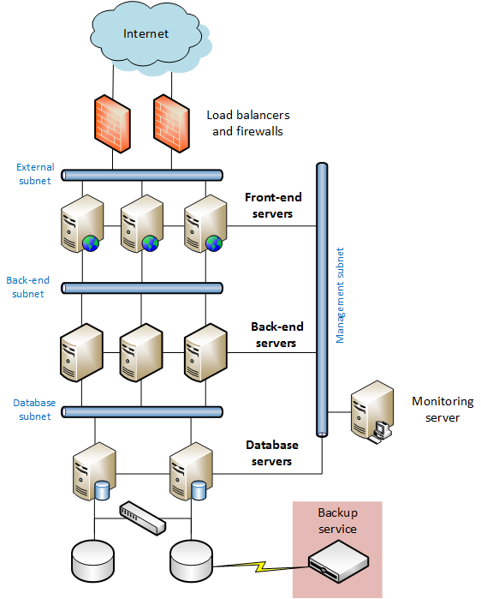

Figure 1 – Architecture diagram for Invote

*NOTE: Change Visio with the appropriate number of machines and delete this comment*

## Platform components

### Voting servers

The configuration of the voting servers is provided in the following table:

|  |  |  |  |  |
| --- | --- | --- | --- | --- |
| Servers | Front-end | Application | Database | Monitoring |
| Machine type | Physical or virtual | Physical or virtual | Physical | Physical or virtual |
| # machines | N | N | N | N |
| # processor cores | N cores | N cores | N cores | N cores |
| Memory | X GB RAM | X GB RAM | X GB RAM | X GB RAM |
| Hard Disk | X GB | X GB | X GB | X GB |
| Network | 3xEthernet 1 Gbps | 3xEthernet 1 Gbps | 4xEthernet 1 Gbps | 2xEthernet 1 Gbps |
| Software | Red Hat Linux 7 / CentOS 7 (64 bits)  Apache HTTP server  OpenSSL  Random Generator Daemon (rngd)  Logs Forward System (Splunk Forwarder)  Zabbix monitoring agent  OSSEC (or another HIDS) | Red Hat Linux 7 / CentOS 7 (64 bits)  Apache Tomcat  OpenSSL  Random Generator Daemon (rngd)  Logs Forward System (Splunk Forwarder)  Zabbix monitoring agent  OSSEC (or another HIDS) | Red Hat Linux 7 / Oracle Enterprise Linux 7 (64 bits)  Oracle Database 11gR2 with RAC  Logs Forward System (Splunk Forwarder)  Zabbix monitoring agent  OSSEC (or another HIDS) | Red Hat Linux 7 / CentOS 7 (64 bits)  Splunk (2 GB/day licence)  Zabbix  Ansible |

*Review the fields in yellow with the matrix "Govlab IT requirements - Sizing" in Excel and delete this*

*Note:* Oracle must be configured to keep a copy of all the information stored on tapes. A new tape should be used every day during the election process. The database encoding must be UTF-8.

Due to the nature of the Invote solution, it is recommended for front-end and application servers to be in a dedicated virtual environment, in the case of opting for virtual machines for its deployment. In this way, each machine can be cloned or stored for data retention policy purposes or for reducing the provisioning time in case that more machines were needed.

Invote portal and Invote back-office have a service check that makes it easier for load balancers to validate whether the application is up and running without any problems. In case there is a failure on the Apache server or individual Tomcat servers, the load balancers (assuming they support “service check” queries) would detect the failed service check response and redirect the connections of the election to another logical branch.

### Network equipment

Scytl is open to using any firewall and load balancer existing in the data centre. These elements will need to support the number of connections required by the voting platform based on client requirements, also allowing sticky sessions and/or persistence based on IP addresses. Scytl does not have preferences about the brand and/or model of these devices. Considering the requirements of the proposal, the minimum bandwidth to access the data centre must be of XXX Mbps.

Regarding the switches, Scytl is also open to using any brand that supports the connection speed required by the servers, and that has enough ports to connect servers (note that each server will have several network connections) and allow VLANs to be created. The switches required for network configuration must include these features:

* Support for creating VLAN (Virtual Local Area Network).
* 1 Gbps connection ports.
* 10 Gbps Uplink port.
* Backplane up to 80 Gbps.

### Storage devices

The following are the requirements for data storage in a disk or SAN:

* Unified Storage Platform.
* Ethernet network cards.
* High Availability features.
* Recommended disk capacity: XXX GB (final size may vary depending on total system load).

## Disaster Recovery Site

**This is an optional item, depending on customer requirements.** Since the Disaster Recovery Site (DRS) must support the same load as the primary site, it must be a replica of that environment. Both data centres must be connected using a high-speed communication channel.

It’s an important requirement for the DRS that its database is synchronized in real time with the primary site database to minimize the time required to change from primary to secondary site (DRS).



Figure 2 – Diagram of connectivity with DRS

# Data Centre required services

In addition to the previously presented components, Scytl requires that the data centre provides the services detailed below:

* Installation of all required hardware and software components. Once everything is installed, Scytl will deploy Invote and all voting components.
* Full system administration:
  + COTS hardware and software 24x7 monitoring.
  + Application updates and patches.
  + Issues and performance reports.
  + Security devices and networks.
* Hardening of all elements.
* Redundant Internet connectivity and assignment of valid IPs visible from the Internet.
* Enough bandwidth for the service. More specifically, for the requirements of this proposal, a bandwidth of at least XXX Mbps is foreseen as necessary.
* Periodic backups.
* Storage of logs (audit logs) of load balancers and firewalls.
* Real-time monitoring of all elements.
* Intrusion detection systems (some firewalls/load balancers include this functionality).
* Allow remote access to Scytl team via VPN/SSH.
* Synchronization with DRS database (if applicable).
* Everything installed in a dedicated rack that should be physically sealed if required by the customer.
* On-site support if required by auditors or third parties in terms of site review, logical sealing and similar tasks.
* Information backup and secure destruction (erasure according to military standards) of the storage media related to the voting process after the election.

# Requirements of voting clients

The voting process can be carried out from standard PCs, smartphones or tablets. Computers can work on Apple, Linux or Windows, although Windows is preferred to allow for an easier interaction. Smartphones and tablets can work on iOS or Android. Compatibility matrix for operating systems and browsers is included in Scytl’s proposal.

The connectivity requirements will ideally be a DSL connection (minimum 128 Kbps) or equivalent. A low-end local firewall could be used as well. The minimum requirements for the computer are as follows:

**Hardware**

* CPU Intel 32 bits.
* 2 GB RAM.
* 60 GB HD.
* Ethernet card.